Cell and Tissue Engineering – Course Project

A 3D brain model for remyelination studies

Yves Greatti

## A – Topic

To better understand myelination, remyelination and demyelination, **NeoCortexBioSystems** have developed a 3D in vitro brain-tissue-like model, **MiniBrain**, mimicking the brain tissue in term of stiffness, viscoelasticity, tensile strength, relaxation time-scales, and adhesion. The product provides simple relationships of myelination levels to biophysical and biochemical properties as key indicators for improving therapeutic studies. Alzheimer’s disease (AD) is the 5th-leading cause of death among individuals age 65 and older[1], and Parkinson’s diseases is the second most common age-related neurodegenerative disorder after AD[2]. This product is a critical tool for drug discovery and targeting in priority older people as the risk of developing neuronal degenerative diseases increases.

**Problem statement**

In the adult brain remyelination happens through either activation of neural progenitor cells (NPCs), which proliferate and differentiate into mature oligodendrocytes (mOLs) or reactivation of resident oligodendrocyte precursor cells (OPCs) which can differentiate in mOLs. This complex OPC differentiation process decreases with aging or disease progression. There are a variety of drugs promoting CNS remyelination in clinical trials and yet oligodendrogenesis is a process not fully understood.

## B – Background

Problem Description

As the older adult population increases in the United States, there is an unprecedented urgency to make significant progress in drug therapies for neurodegenerative diseases (NDD). Today, in the United States, there are about more than 1 million people suffering from Parkinson disease and 5.3 million cases of Alzheimer’s disease (Institute for Neurodegenerative Disorders). By 2050, the number of Alzheimer’s patient will be increased 4-fold.

**Figure 1: the burden of Alzheimer’s disease**

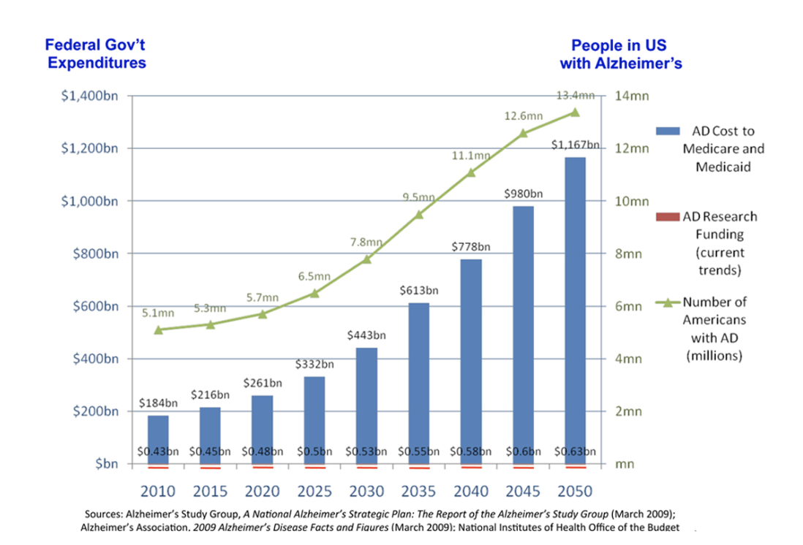

NDD is caused by autoimmune inflammatory damages against myelin in the central nervous system (CNS). Thus, pharmaceutical research of drugs promoting CNS remyelination, or screening methods for anti-inflammatory agents as well as methods to deliver efficiently these drugs to site of neuroinflammation or degeneration, could improve significantly patient’s life by delaying or even preventing neurodegeneration.

Motivation

In 2021, the Neurodegenrative Disease Market was valued at approximatevely USD 39 billions according Zion Market Research study and is estimated to grow to about USD billions by 2028.

**Figure 2: CNS Therapeutic Market Size**

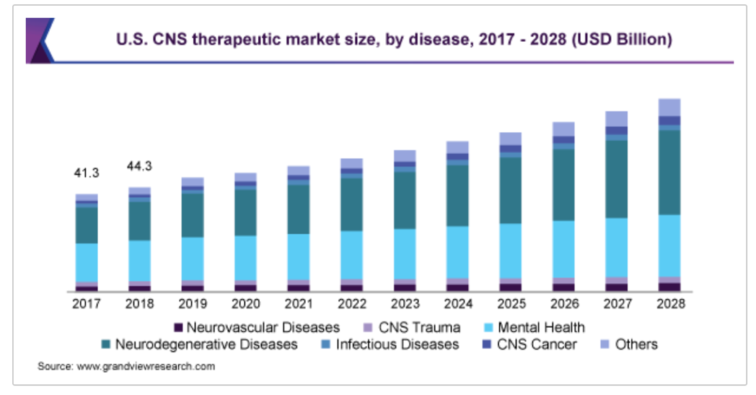

## C – Solution Landscape

|  |  |  |  |
| --- | --- | --- | --- |
| **Description** | **Advantage** | **Disadvantage or GAP** | **Reference** |
| **Title (you can come up with a short descriptor if the technology doesn’t have a name)**  1-2 sentences describing the  Solution | * Bulleted list | - Bulleted list | Include patent number, bibliography style reference or  company website. |
| **Title (you can come up with a short descriptor if the technology doesn’t have a name)**  1-2 sentences describing the  Solution | * Bulleted list | - Bulleted list | Include patent number, bibliography style reference or  company website. |
| **Title (you can come up with a short descriptor if the technology doesn’t have a name)**  1-2 sentences describing the  Solution | * Bulleted list | - Bulleted list | Include patent number, bibliography style reference or  company website. |
| **Title (you can come up with a short descriptor if the technology doesn’t have a name)**  1-2 sentences describing the  Solution | * Bulleted list | - Bulleted list | Include patent number, bibliography style reference or  company website. |
| **Example**  **Meso Biomatrix Scaffold** Kensey Nash is developing a porcine mesothelaial matrix for  soft tissue repair including nerve  conduits. | * naturally-derived matrix facilitates cell infiltration and growth factor retention * easy to handle surgically (short hydration time durable, deformable) | - matrix material is derived from another animal (pig) | http://www.kense ynash.com |

[table]

Table with 5 distinct solutions.

[text]

Summary of descriptions, advantages, disadvantages, references. A well-written paragraph summarizing and referencing the content in the table

Include a careful consideration of the advantages and disadvantages of each solution. Review the logical argument of the text to provide contrast between the solutions and a gap analysis/description.

Provide a thoughtful summary and analysis of the differences in the available solutions.

Use the text section to do more than just *repeat* the information in the table in the summary paragraph – use the text section to describe trends and gaps in the table to set up a natural conclusion of how your selected product is able to address those gaps. It may be helpful to organize the section into smaller paragraphs for each specific gap you have identified.

## D – Solution Description

|  |  |  |  |
| --- | --- | --- | --- |
| **Need / Criteria** | **Unit of Measure** | **Ideal Value / Range** | **Reference** |
| **Title**  1-2 sentences describing the criteria |  | - | Include bibliography style reference |
| **Title**  1-2 sentences describing the criteria |  | - | Include bibliography style reference |
| **Title**  1-2 sentences describing the criteria |  | - | Include bibliography style reference |
| **Title**  1-2 sentences describing the criteria |  | - | Include bibliography style reference |
| **Example**  **Thrombogenicity**  Indwelling vascular catheter should not cause thrombosis. This is a severe safety risk to the patient. | * mg of thrombus formation in animal study | - none or less than a legally marketed comparator device | Preclinical Device Thrombogenicity Assessments: Key Messages From the 2018 FDA, Industry, and Academia Forum, ASAIO Journal |

[table]

Table should include 4-6 thoughtful and critical design criteria. Criteria should also align with the requirements and constraints of the clinical problem. Criteria should include specific descriptions, scientific details, quantitative/functional criteria, and references for how the solution meets the criteria. Table should be filled out completely.

[paragraph text]

Summarize the process of selecting the design criteria and the associated metrics (based on the clinical need/problem statement). It’s important to include references to support the choice of these design criteria. Try to be specific to the CTE criteria we’re studying in the course and the identified problem statement and not address medical treatments in general.

Describe *how* the solution/specific CTE product works. Provide details on how the solution functions (mode of action).

Describe how the design of solution matches up with the design criteria. Explain the correlation between the function/design of the solution and the selected design criteria.

## E – Verification and Validation

There is often a lot of information you can include in this section. It needs to be structured into a logical analysis showing the verification and validation success, in *technical* detail, as a take home "This really works" message to the reader.

How do these studies map to specific, quantitative, design criteria from the solution description?

Verification

[Use subheadings for each part]

Verification is typically a bench or animal study, where you are assessing the quantitative feature/specification of the device itself - thickness, bioactive proteins, strengths, biocompatibility, etc. Not typically clinical trials, those are validation.

Use the text to describe at least one key verification study. Explain how the reported data demonstrates the *most* important aspect for proof of concept. Show how the data connects to the design inputs.

Please focus on at least one quantitative verification and provide details on the method, outcome, and connection to design requirements. It helps to include at least one specific quantitative example from the papers and connect that example to the intended design parameter for that metric.

Validation

Describe the methods and outcomes of at least one validation study. Connect the methods and outcomes to the needs of the intended population described earlier in the project.

If the company/lab have not published clinical trial results, then focus on the specific parallels, methods, and outcome from the available studies to the eventual human population.

**Wrapping up:** A concluding summary of the verification function and the validation scope (relating the validation to the patient population in the Background section) would be helpful. This section is almost the end of the paper so really try to give the reader a take home "it works" message.

## Conclusions

[Only submitted in the final report]

Provide a short closing paragraph which summarized the key-take-away messages from your analysis and ties the whole project together. Link back to the problem statement.

## References

1. [use MLA format]

1. Alzheimer’s Association, 2022 Alzheimer’s Disease Facts and Figures.
2. Parkinson’s Foundation